The use of SDC’s at [www.uit.no](http://www.uit.no) > Drupal 11

Necessary modules:

* UI Patterns
* SDC Block
* Paragraphs
* Paragraph Blocks
* CKEditor 5 Plugin pack
* CKEditor 5 Template
* Layout Builder Base (for å konfigurere flere layouts, background, margins osv.)
* Layout Builder Styles
* Layout Builder Modal
* Block List Override
* Section Library (for å lagre sections til gjenbruk)
* Layout Paragraphs
* View Mode Switch (for å byte view mode gjennom skjema)
* Views Token Argument (for å lage avanserte entity-koblinger i Views)
* (Dropsolid Rocketship)
* (Drupal CMS XB)
* (Pixel Onion Page Builder)
* (Focal point)
* (Entity usage)
* field group
* inline entity form
* conditional field
* <https://www.youtube.com/watch?v=ct-i3YEgGuQ>  
  Vi bør kanskje lage et eget Text-filter for superbrukere KAN
* Token Filter (i CKEditor -> filter format)
* Field Token Value (legge tokens inn i Field)
* Field Toke OR (når flere fields er lenket sammen, går ned stakken)
* Custon Tokens
* (Custom Field)?

SDC:

Når du bruker Paragraphs i SDC så kan du gjerne gjenbruke fields (paragraph fields):

To render content array, but skip repeating rendering of earlier used fields:

## Views theming

<https://www.youtube.com/watch?v=zriU19dViC8>



views-view.html.twig (whole view)

->views-view--feautered-news.html.twig

->views-view--feautered-news--block-1.html.twig

||

1.13.05

views-view-unformatted.html.twig (= the view format, f.eks. table, uformatted++)

||

views-view-fields.html.twig (alle felter i en rad håndteres av denne twiggen)

-> views-view-fields--featured-news--block-1.html.twig (affekterer bare block-1)

Husk: bilder må formateres til url:

||

views-view-field.html.twig

T. twig.symfony.com -> twig dokumentasjon

1. html.html.twig: "I set body_classes variablen legges følgende til": 'container m-auto grid grid-cols-5'

2. page.html.twig: <div class="layout-container max-w-[1440px]">

container m-auto grid grid-cols-5 gap-4 px-8

3. Twig Tweak, render block with {{ drupal_entity('block', 'uit_rhr_site_branding') }}

4. Use module "block class" to put in css class to handle placement

5. No markup module

6. block.html.twig legger til en div som wrapper, kan fjernes

7. kan håndteres på høyere detaljeringsnivå, f.eks. i block--system-branding-block.html.twig

8. header menu: add "theme hook suggestion" header_menu with menu_block module, generate corresponding twig file, tweak it to its needs

block--menu-block--main-header.html.twig

menu--main-header.html.twig

9. slå av "Site name" og "Site slogan" for site branding, i Home | Administration | Structure | Block | layout

10. **View Mode switch – module**

**11. Field Group - module**

11. Paragraphs Table, Paragraphs grid - module (needed, but can handle manually)

-> create (copy) specific twigs:

-> dump variable content:

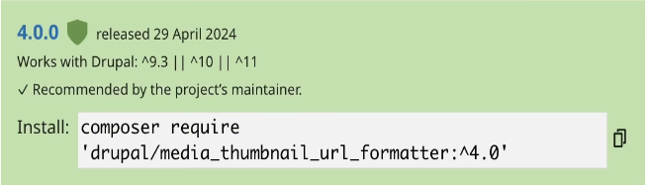

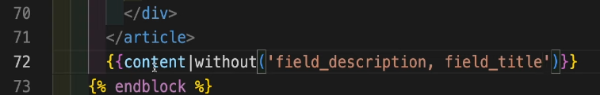

1.48.20 Paragraphs

12. Components: HyperUI

13. Module: media_thumbnail_url_formatter

14. Module: Views reference field

15. SDC, T:daisyUI nettside: daisyui.com

16. composer require 'drupal/entity_usage:^2.0@beta'

17. Module: sdc_display

-> drush generate single-directory-component

SDC <-> Paragraphs fra tailpine (A)

Den ovenfor brukes til input i denne, cta.twig

Nested paragraphs, in header (bundle) paragraph:

Siste del:

SDC with slot needs to be embedded this way (tp -> sdc single day):

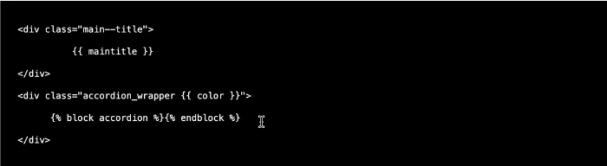

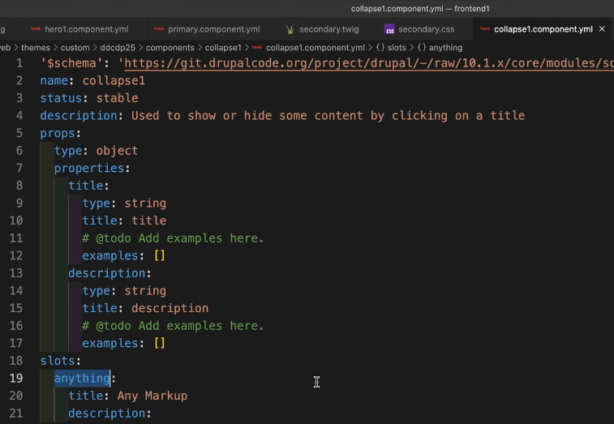

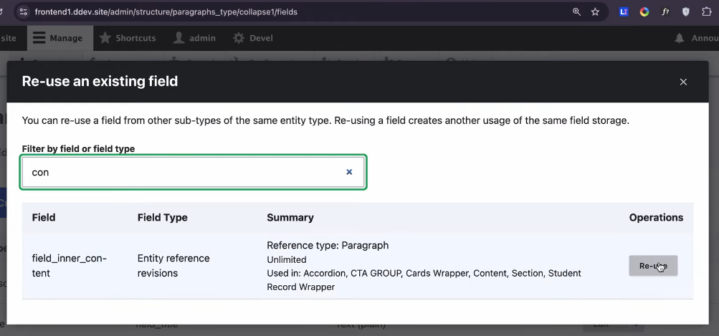

Tips: for å få frem link fra drupal-link-objekt:



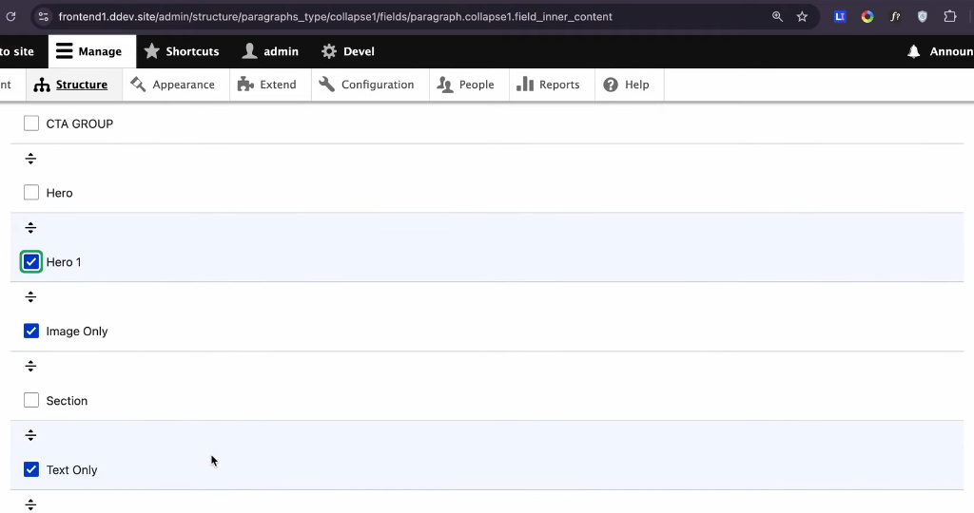

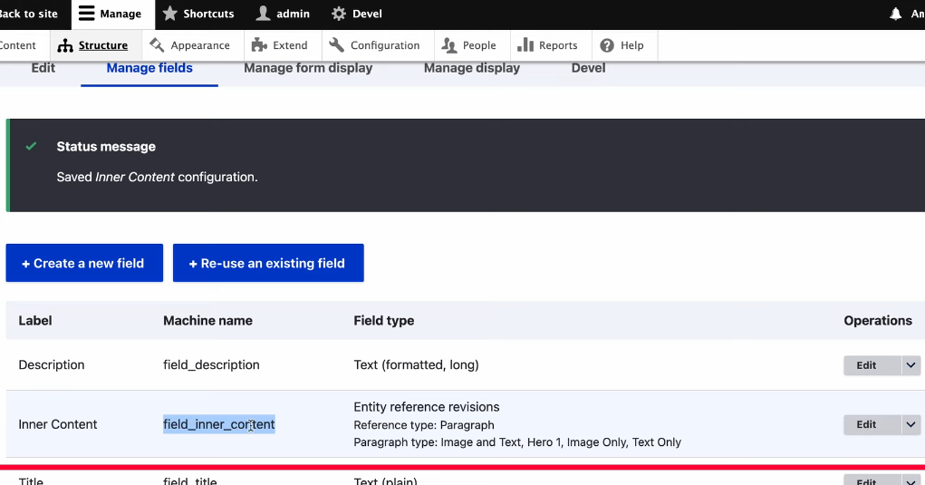

Sendes til slot!

Generate nested object to render in SDC’s: 1:37:00

* Twig Template Suggester (module)
* View mode switch field (1:52.23)
* SDC Block module (<https://www.youtube.com/watch?v=uo02fTChNgE> ; 12:47)
* SDC Display (-“-; 26:11)

**Slot – make placeholder and use:**

Good explanation: (<https://www.youtube.com/watch?v=uo02fTChNgE> ; 14:50)

[Ivan Duarte (Drupal director at Agileana)] /opt/drupal/web/core/profiles/demo_umami/themes

(component-navn: intro_section)

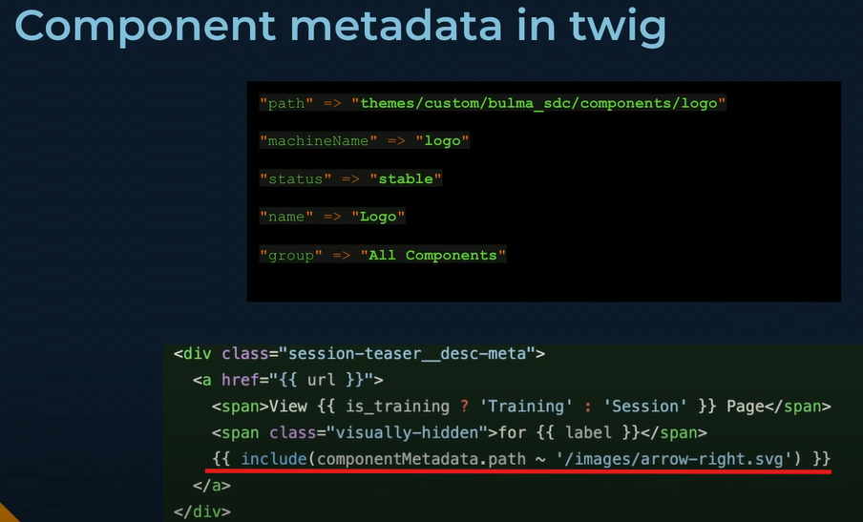

### Include a component from a paragraph:

